POSTING REMINDERS:
- Remember to tag the Imperial PFS account in your LinkedIn post. To do that, you will type in @ImperialPFS which should populate a drop-down menu to select the account you wish to tag. Once you do that, the @ symbol will disappear and the Imperial PFS will appear in bold (which should serve as a link to the IPFS account).
- Hashtags are a way to create trackable content on social media. When attending an event or tradeshow, we recommend that you utilize any hashtags that the event or tradeshow has created for their promotions in addition to the standard IPFS hashtags, which are: #premiumfinance #ipfs

Content Library
The sections and corresponding tables below are meant to help guide you as you work to create and share content on your own LinkedIn pages. Please note that the sample images included to the left of each content piece are intended to provide you with inspiration for your posts. Your LinkedIn account helps to showcase your role with IPFS, please adopt this content and edit it to make it your own. You can access these images on the Marketing PENN page to download and save them onto your device.

You can seamlessly access a pool of posts ready to share directly on LinkedIn. See below for details! Content that is available for sharing on LinkedIn is updated regularly, so be sure to check back for fresh post ideas each quarter.

IPFS PRODUCTS AND SERVICES
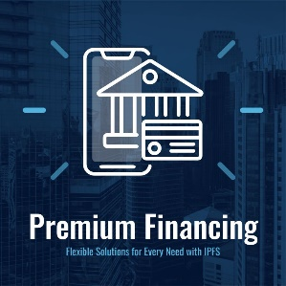 | I'm ready to help you sell more policies and increase your bottom line. Our premium financing, payments, and solutions are designed to streamline your business operations and enhance the experience for your insureds. Imperial PFS combines cutting-edge technology with premium financing and payments to bring you an exceptional client experience.  Let's chat...
 | Did you know Imperial PFS offers a single suite of solutions for your premium financing, payment, electronic signature, and document and delivery needs so we can take the heavy lifting off of your back-office processes to make your work life a little bit easier?  I'm here to help! Let's chat...
 | I’m passionate about helping insurance agents find solutions that work. With Imperial PFS, you can offer your insured customers options for paying their insurance premiums and leverage the power of flexibility when it matters the most.  When you’re ready, I’m here.
 | I'm proud of what we do here at Imperial PFS. Every day, I work with insurance agents knowing it's making an impact on their business and the lives of the customers they serve. If you're ready to learn more about how premium financing, payments, and technology can elevate your business - let's connect.
 | Imagine having ONE platform that combines the ability to finance insurance premiums and offers flexible payments for your insureds. Those are just a couple of the benefits you'll have with Imperial PFS.  Ready to learn more? Let's talk.
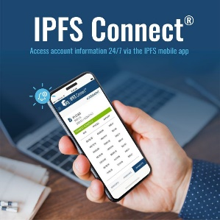 | Access your IPFS accounts anytime, anywhere with IPFS Connect. Our free app is easy to use and designed to save you valuable time. I’m here to help you make the most out of your experience with IPFS. Let me know if you have any questions about accessing our mobile app.  Available for download on both Google Play and the App Store.
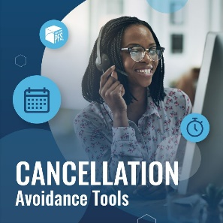 | I’m committed to helping you make the most out of the tools and resources available to you through Imperial PFS. Our cancellation avoidance tools are designed to help you streamline your communications and make your workday just a little bit easier.  Leverage the IPFS® resources available to you and your insureds, including:  · Text Message and Email Alerts  · Impending Cancellation Reports  · Quick & Easy Payment Methods  · Notice of Intent to Cancel  · Convenient Hold Feature  · Make a Payment on Behalf of Your Insured  Connect with me to learn more!
 | Did you know you can obtain CE credits for free with Imperial PFS? We’ll even file the required state forms for you on your behalf.  Current CE Offerings:  -Premium Finance Options  -Premium Finance Express  -Premium Finance at a Glance  -The Fundamentals of Ethics  -Avoiding E&O Loss  Connect with me for more details!

I’M IN TOWN
These examples are intended to help you create your content when you’re out in the market and are not available in the IPFS LinkedIn Library on PENN.
 | Excited to head to Colorado Springs to talk all things premium finance, payments, and insurance solutions…and maybe take in a quick hike at Garden of the Gods. I’ve got a few spots open to connect. If you’re ready to transform your business and leverage the power of ONE platform to meet your needs – let’s chat. #ipfs #premiumfinance
 | I’ll be stopping through STL Tuesday 8/20 and Wednesday 8/21 for a few meetings. Would love to grab a drink and talk all things premium finance and payments with you while I’m in town. Ready to connect? The coffee is on me! #STL #IPFS #PremiumFinance #Insurance
 | Looking for food recommendations in OKC while I’m in town next week for meetings. What’s the best spot for local eats? I’m excited to explore the city, find a new favorite spot, and connect with local agents about insurance premium financing and payment solutions. Let me know if you want to synch up – dinner is always better with company!  Got any ideas, Independent Insurance Agents Association of Greater Oklahoma City? #IIAAOKC #IPFS #LetsConnect #PremiumFinance #InsuranceSolutions

CONVENTIONS & TRADESHOWS
When attending conventions or tradeshows, we recommend that you repost (select “repost with your thoughts”) an existing post from the event owner (this will show up for people who are following their page) in a public post of your own expressing your excitement to be attending the event.
Example content:
I can’t wait to talk about premium finance with you at the World Summit 2024! Our team will be there to connect and share Imperial PFS tools and solutions that will help make your business operations easier. Find me at booth #259B on Tuesday 8/26!
#premiumfinance #insurancesolutions #ipfs #worldsummit24

GOLF TOURNAMENTS & EVENTS
When attending events, we recommend that you repost (select “repost with your thoughts”) an existing post from the event owner (this will show up for people who are following their page) in a public post of your own expressing a sentiment on why you are excited to be part of the event.
Example content:
Looking forward to par-teeing with you at the Third Annual IINCA Golf Tournament on April 22nd, sponsored by Imperial PFS. Stop by and grab some un-fore-gettable swag and say hi – we’re excited to see you there!

Accessing the “My Company” tab on LinkedIn:
- Log into your existing LinkedIn account
- Navigate to the Imperial PFS page on LinkedIn
- Select the “My Company” tab
- Select “Verify email address” and enter your IPFS email address
- Select “Send Code”
- Check your IPFS email to access the verification code from LinkedIn
- Enter the code and click “Confirm”

Successful verification will reroute you to the “My Company” tab on LinkedIn.

Sharing Recommended Content on LinkedIn:
- Log into your existing LinkedIn account
- Navigate to the Imperial PFS page on LinkedIn
- Select the “My Company” tab
- Navigate to the “Recommendations from Imperial PFS” section
- Select “Start a post”
- Select “Post”

